**SVKM’s NMIMS**

**Mukesh Patel School of Technology Management and Engineering, Mumbai**

**Department of Electronics & Telecommunication**



**Programming for Problem Solving (Exp 3-2)**

|  |  |
| --- | --- |
| **Roll No: J001** | **Name: Adith Ramakrishna** |
| **Program: B. Tech Data Science (1st)** | **Batch: J1** |
| **Date of Experiment: 04/10/2022** | **Date of Submission: 04/10/2022** |

**Task 1:**

1. **using namespace std;** is missing

**void main()** cannot return 0 it has to be **int main()**

Extra semicolon after **switch(choice)**

1. **using namespace std;** is missing

**void main()** cannot return 0 it has to be **int main()**

**Invalid datatype** for case inside switch (It should be char and enclosed with single quotes)

1. **using namespace std;** is missing

**Task 2:**

1. **Default:**
2. **Hello**

**Ok**

1. **Default block executed**

**Task 3:**

|  |  |
| --- | --- |
| if ( node == 15)  { curValue += 5;  Count++;  }  else if (node == 40)  { curValue *= 1.5;  Count++;  }  else  curValue -= 2; | switch(node) {  case 15:  curValue += 5;  break;  case 40:  curValue *= 40;  break;  default:  curValue -= 2;  break;  } |
| if (grade == 'A')  cout<<"Very good";  else if (grade== 'B')  cout<<"Good";  else if (grade == 'C')  cout<<"Moderate";  else  cout<<"Try harder!"; | switch(grade) {  case ‘A’:  cout<<"Very good";  break;  case ‘B’:  cout<<"Good ";  break;  case ‘C’:  cout<<"Moderate";  break;  default:  cout<<"Try Harder!”; } |

**Task 4:**

#include <iostream>

using namespace std;

int main() {

int weeknumber;

cout << "Enter week number(1-7): ";

cin >> weeknumber;

switch (weeknumber) {

case 1:

cout << "Monday";

break;

case 2:

cout << "Tuesday";

break;

case 3:

cout << "Wednesday";

break;

case 4:

cout << "Thursday";

break;

case 5:

cout << "Friday";

break;

case 6:

cout << "Saturday";

break;

case 7:

cout << "Sunday";

break;

default:

cout << "Invalid input!";

}

return 0;

}

**Task 5:**

# include < iostream >

using namespace std;

int main() {

char op;

float num1, num2;

cout << "Enter operator: +, -, *, /: ";

cin >> op;

cout << "Enter two operands: ";

cin >> num1 >> num2;

switch (op) {

case '+':

cout << num1 << " + " << num2 << " = " << num1 + num2;

break;

case '-':

cout << num1 << " - " << num2 << " = " << num1 - num2;

break;

case '*':

cout << num1 << " * " << num2 << " = " << num1 * num2;

break;

case '/':

cout << num1 << " / " << num2 << " = " << num1 / num2;

break;

default:

cout << "Invalid Output!";

break;

}

return 0;

}

**Task 6:**

#include <iostream>

#include <cmath>

using namespace std;

int main() {

int choice;

float num;

cout << "Enter choice: \n1 - Square Root of number\n2 - Power of number\n";

cin >> choice;

cout << "\nEnter number: ";

cin >> num;

switch (choice) {

case 1:

cout << "\nSquare Root: " << sqrt(num);

break;

case 2:

cout << "\nPower: " << (num * num);

break;

default:

cout << "\nInvalid Output!";

break;

}

return 0;

}

**Home Work Questions:**

**1.**

**Algorithm:**

**Step 1: start**

**Step 2: read marks or Percentage**

**Step 3: if marks >= 80 then grade =A, go to step 7**

**Step 4: if marks >= 60 and marks <=80 then grade = B, go to step 7**

**Step 5: if marks >=40 and marks <=60 then grade = C go to step 7**

**Step 6: display failed**

**Step 7: display grade.**

**Step 8: stop**

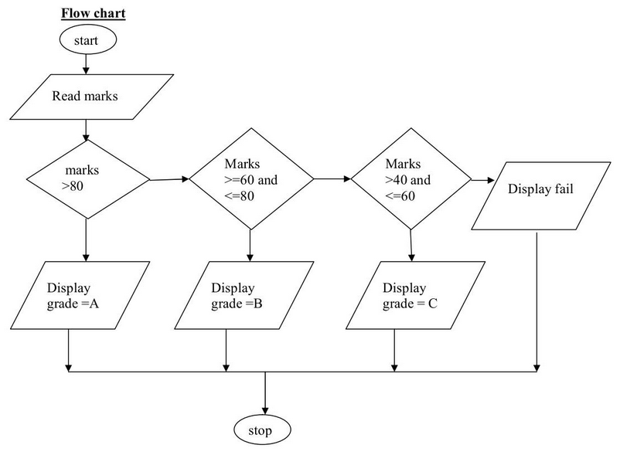

**Code:**

#include <iostream>

int main()

{

int num;

cout << "Enter your mark: ";

cin >> num;

if(num >= 80){

cout << "\n You got A grade \n";

}

else if (num >=60){

cout << "\n You got B grade \n";

}

else if (num >=40){

cout << "\n You got C grade \n";

}

else if (num < 40){

cout << "\n You Failed in this exam \n";

}

return 0;

}

**2.**

#include <iostream>

using namespace std;

int main() {

char c = 'B';

if (c == 'a' || c == 'e' || c == 'i' ||c == 'o' || c == 'u' || c == 'A' || c == 'E' || c == 'I' || c == 'O' || c == 'U')

cout <<c<< " is a Vowel" << endl;

else

cout <<c<< " is a Consonant" << endl;

return 0;

}

**3.**

#include<iostream>

using namespace std;

int main()

{

int shape;

cout<<"Enter the shape:\n1 - Rectangle\n2 - Circle\n3 - Triangle\n4 - Square\n";

cin>>shape;

if(shape==1)

{

float length, breadth;

cout<<"Enter the length\n";

cout<<"Enter the breadth\n";

cin>>breadth;

float area = length * breadth;

cout<<"The area of the rectangle is ";

cout<<area;

}

else if(shape==2)

{

float radius;

cout<<"Enter the radius of the circle\n";

cin>>radius;

float area = 3.14 * radius * radius;

cout<<"The area of the circle is ";

cout<<area;

}

else if(shape==3)

{

float base, height;

cout<<"Enter the height of the triangle\n";

cin>>height;

cout<<"Enter the base of the triangle\n";

cin>>base;

float area = base * height * 0.5;

cout<<"The area of the triangle is ";

cout<<area;

}

else if(shape==4)

{

float side;

cout<<"Enter the side of the square\n";

cin>>side;

float area = side * side;

cout<<"The area of the square is ";

cout<<area;

}

return 0;

}